Insert the two opposite coordinates of a rectangular area into points.csv as

|  |  |  |
| --- | --- | --- |
| P1 | Latitude(P1) | Longitude(P1) |
| P2 | Latitude(P2) | Longitude(P2) |

Point P1 and P2 are as shown below.

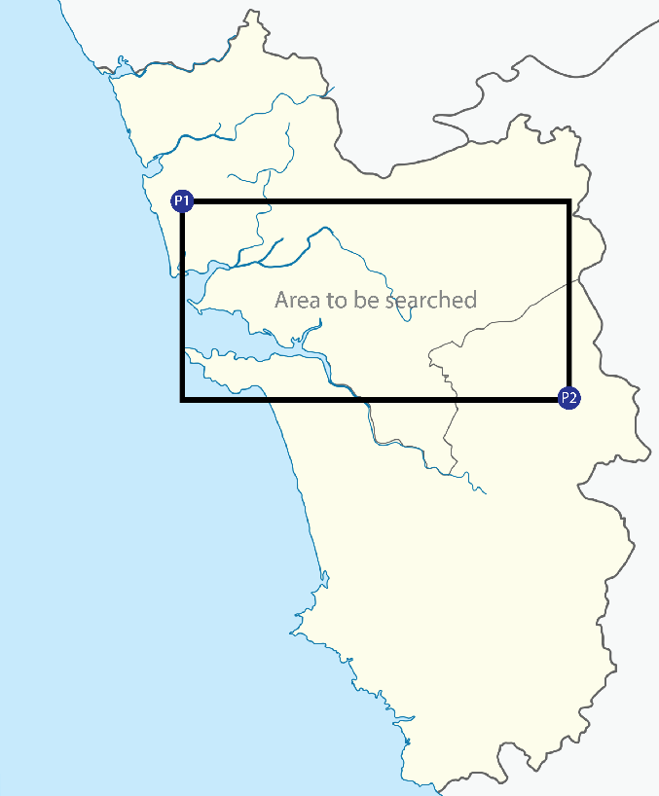

*image isn’t scaled

It seems that you cannot get the data properly beyond the radius of approximately 1 km.

I am going to stick with the data from a region enclosed by a circle of radius 1 km around it’s center.

So first, I will generate multiple circles using ***map_points*** situated in ***map_splitter.py*** such that the complete area is covered.

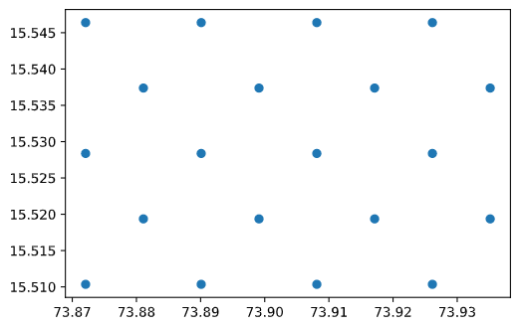

So, I am trying to capture the data by making repetitive calls to the API, such that it can cover the whole area as following

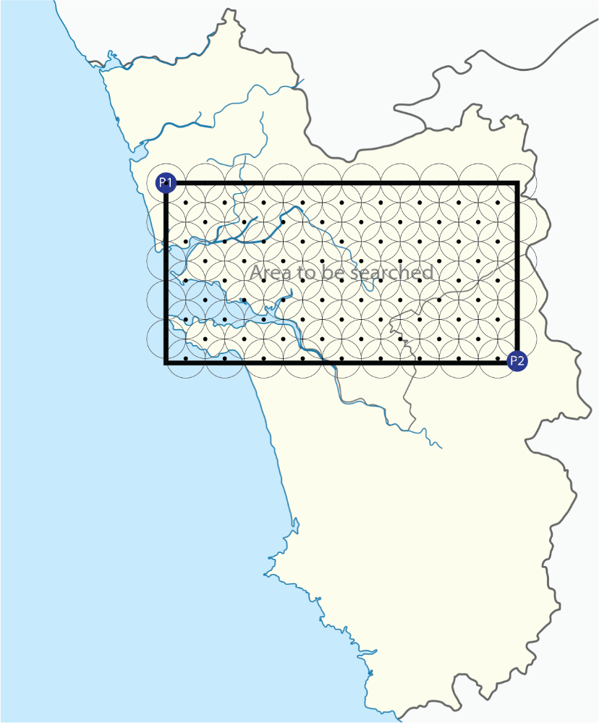

*image isn’t scaled

Thus, covering the complete area.

As you can see a small area requires a lot of map points and so I don’t recommend doing this over a larger area, as it will make a lot of API calls this increasing the traffic as well as making the whole process a bit slow.

The entity points are stored in the ***‘entity types.csv’*** file. By default it will read all the points of interests and their entity codes and extract the information.

It stores all the json files into the ***‘json files’***  directory according to entity type and it will save all the output data to the ‘***output***’ directory with filenames as ‘***[entity type].txt***’

The file ‘***output/1.count***’ stores the counts of all the Entities found